Penetration Testing Report – Passive Reconnaissance Phase
Target Information
- Domain Name: aliasghargroup.com
- Registrar: DreamHost, LLC
- Domain Creation Date: 2025-08-27
- Domain Expiration Date: 2026-08-27
- Registrar WHOIS Server: whois.dreamhost.com
- DNSSEC: Unsigned
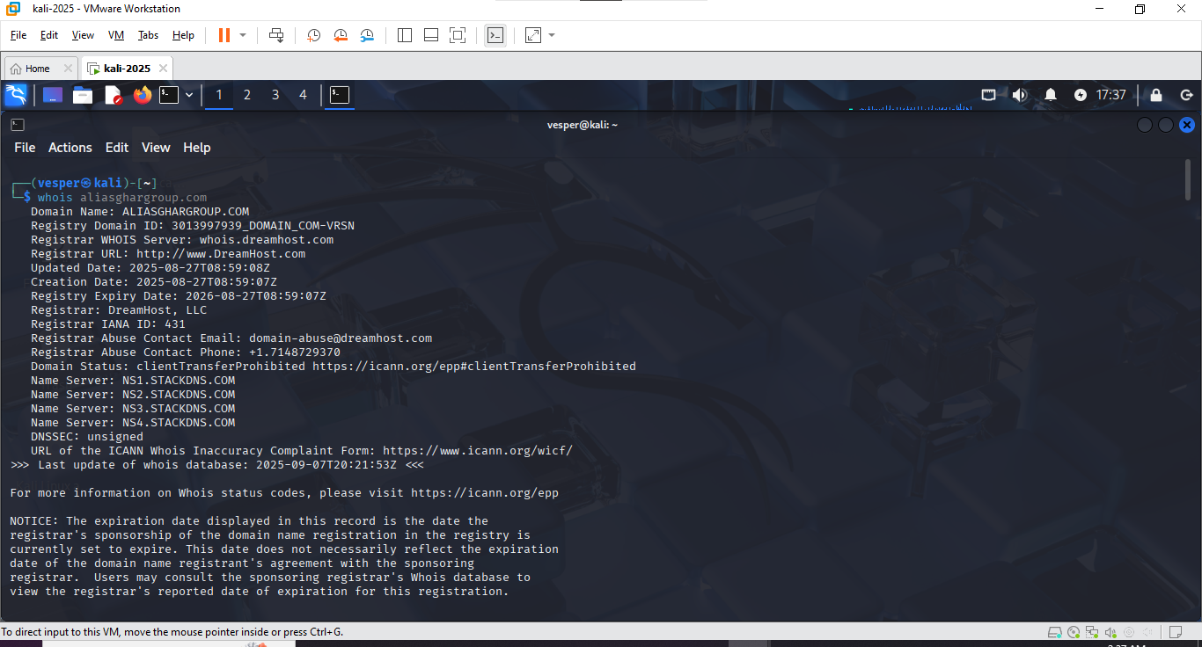
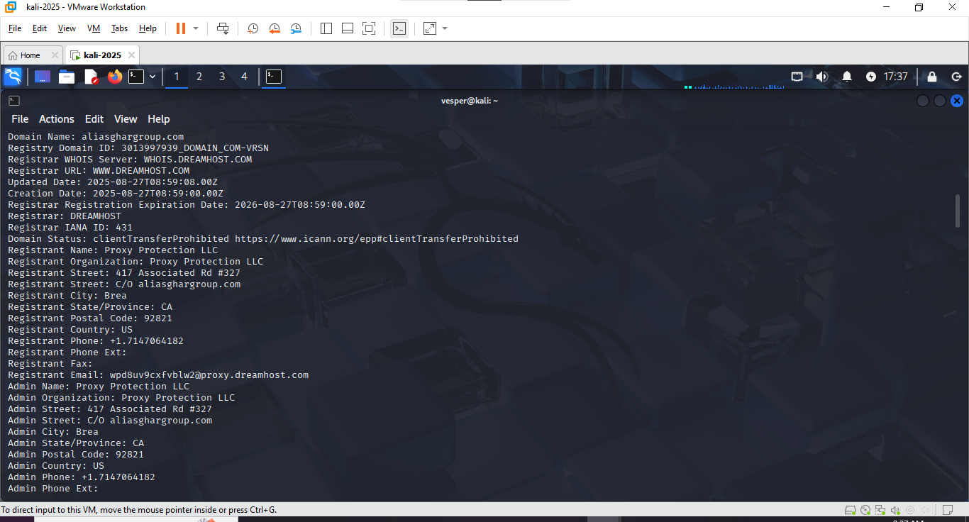

1. WHOIS Lookup
A WHOIS lookup was performed to identify the domain registrar, creation date, expiration, and administrative contacts.
- Registrar: DreamHost, LLC
- Domain Status: clientTransferProhibited
- Registrant: Proxy Protection LLC (information obfuscated via privacy service)
- Contact Email: wpd8uv9cxfvblw2@proxy.dreamhost.com
Key Findings:
- Recently registered (27 August 2025).
- Protected via proxy (no direct owner information).
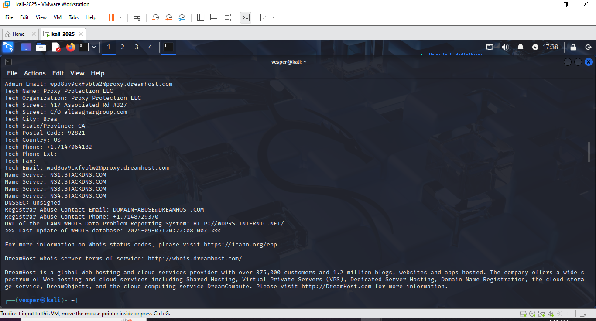

2. DNS Records
A Record (IPv4 Address)
- IP Address: 185.151.30.186
Command Used:
dig aliasghargroup.com
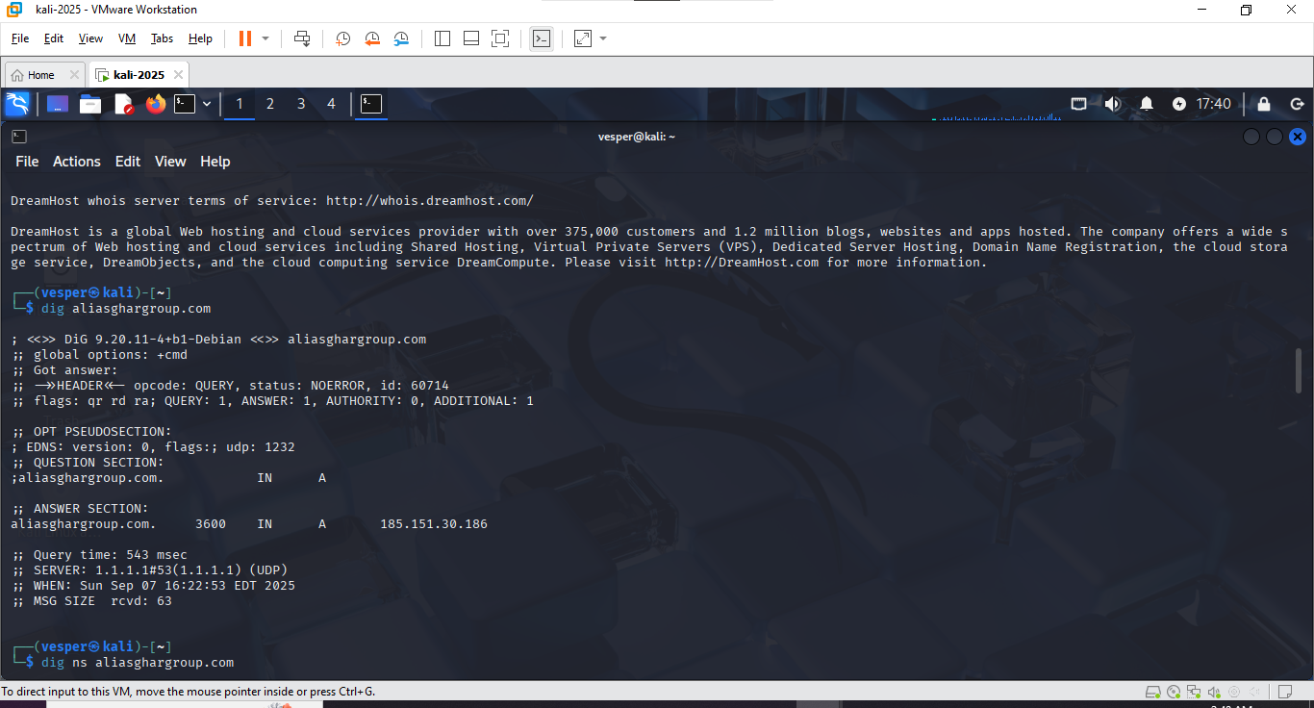
Name Servers (NS)
- ns1.stackdns.com
- ns2.stackdns.com
- ns3.stackdns.com
- ns4.stackdns.com
Command Used:
dig ns aliasghargroup.com
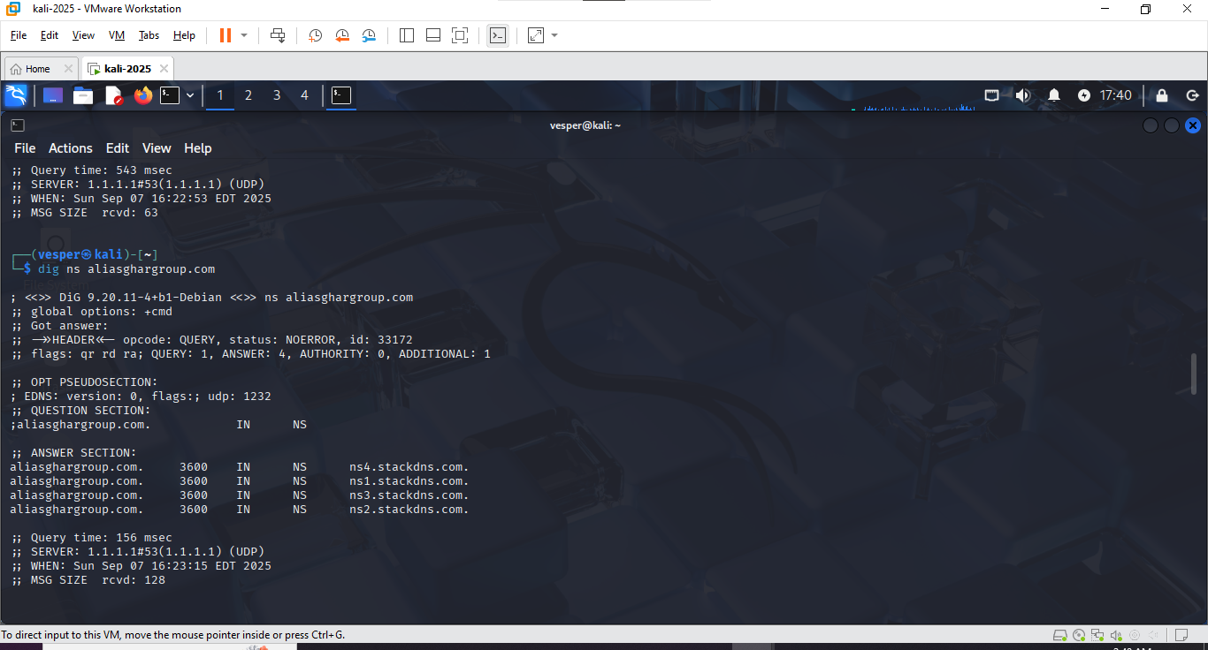
Mail Exchange (MX)
- Mail Server: mx.stackmail.com (Priority: 10)
Command Used:
dig mx aliasghargroup.com
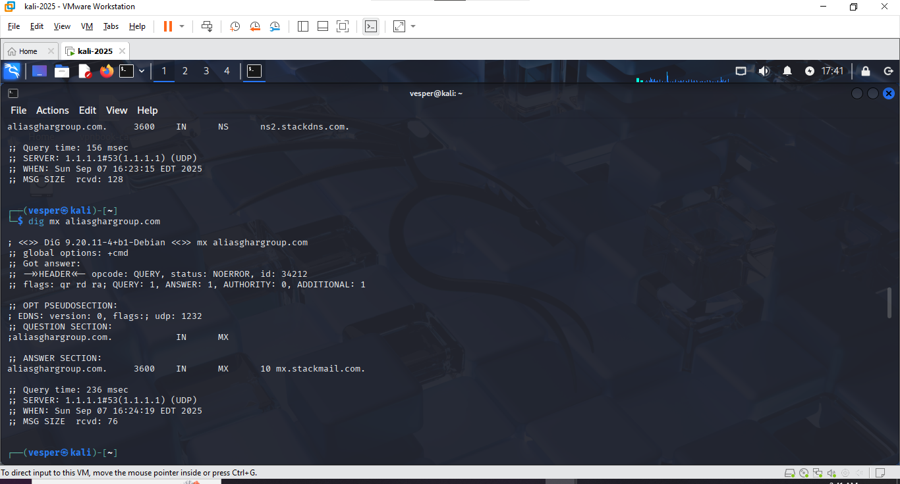

3. Technology Fingerprinting
Using whatweb, the following technologies were identified:
- Web Server: Apache
- CMS: WordPress 6.8.2
- Framework: Bootstrap 1.6.3
- PHP Version: 8.2.29
- JavaScript Library: JQuery 3.7.1
- Plugins: Elementor 3.31.3, Redux 4.5.7
Emails Found:
- contact@mysite.com
- info@aliasghargroup.com
Command Used:
whatweb aliasghargroup.com
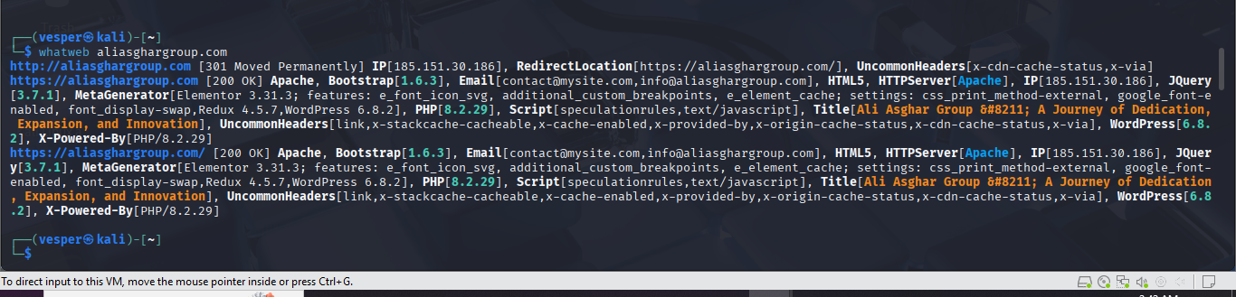

4. SSL/TLS Certificate Analysis
- Issuer: Let's Encrypt R13
- Subject: *.aliasghargroup.com
- Valid From: 27 August 2025
- Valid To: 25 November 2025
- Key Size: RSA 2048-bit
- TLS Version: 1.3
No issues found with certificate verification (status: OK).
Command Used:
openssl s_client -connect aliasghargroup.com:443
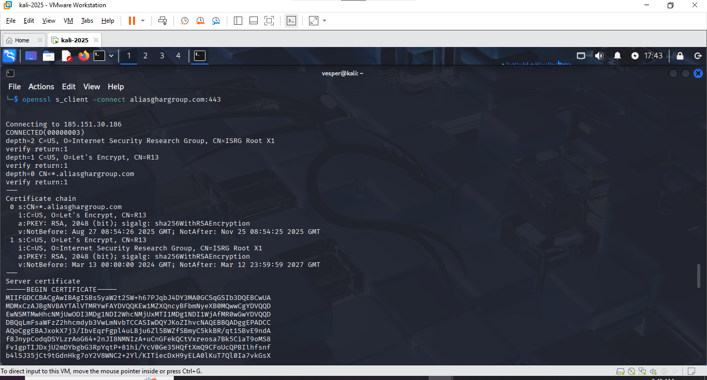
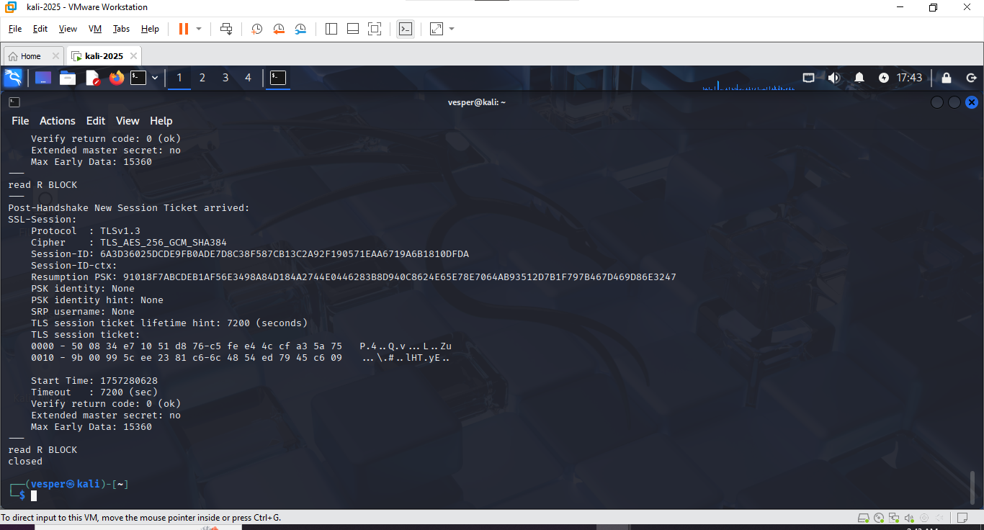

Summary of Passive Reconnaissance Findings
- Domain and infrastructure appear to be newly set up and maintained via DreamHost.
- Web server is Apache running WordPress with Elementor and Redux plugins.
- SSL/TLS is correctly configured using Let's Encrypt with a wildcard certificate.
- No obvious misconfigurations detected in passive recon stage.

